- Add the five star next to the logo at the top left similar to this site. https://www.webloftdesigns.com/

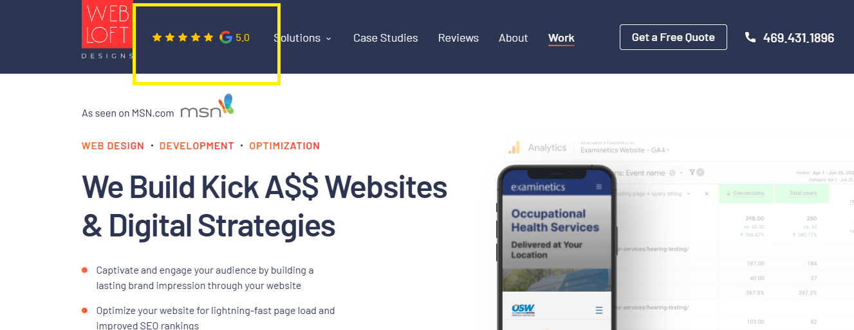

- I want to have a Services areas similar to this

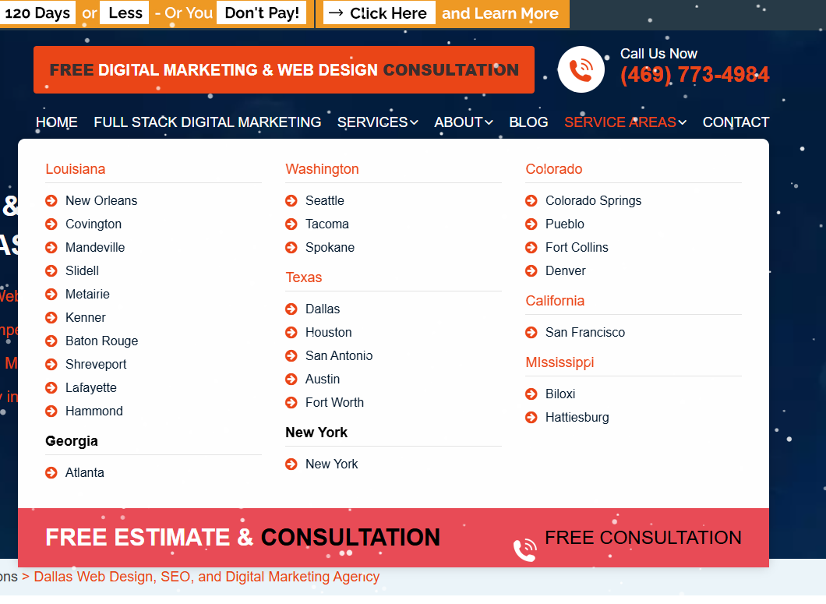

Ideas for Pixl new site https://themenectar.com/salient/agency/
From https://themeforest.net/item/salient-responsive-multipurpose-theme/4363266

- Update logo

